**DAILY ONLINE ACTIVITIES SUMMARY**

|  |  |  |  |
| --- | --- | --- | --- |
| **Date:** | 21/06/2020 | **Name:** | Krishnitha |
| **Sem & Sec** | 4th sem, A Section | **USN:** | 4AL18CS039 |
| **Online Test Summary** | | | |
| **Subject** | NA | | |
| **Max. Marks** | NA | **Score** | NA |
| **Certification Course Summary** | | | |
| **Course** | Software Development Engineer | | |
| **Certificate Provider** | AWS Educate | **Duration:** | 3 hrs |
| **Coding Challenges** | | | |
| **Problem Statement:**  Write a C Program to rotate a Matrix by 90 Degree in Clockwise or Anticlockwise Direction. Implement (Both the rotations in single program using switch case statement). | | | |
| **Status:** Executed | | | |
| **Uploaded the report in GitHub** | | YES | |
| **If yes Repository name** | | <https://github.com/krishnitha/C-coding> | |
| **Uploaded the report in slack** | | YES | |

**Certification Course Details:**

Today I have started the new course “Software Developer Engineer” by AWS Educate. In this course today I learnt about Software development in mobile and gaming and also about programming and scripting of software development. Today I have completed two modules of this course. And I have also completed the assessments of this modules of the course.

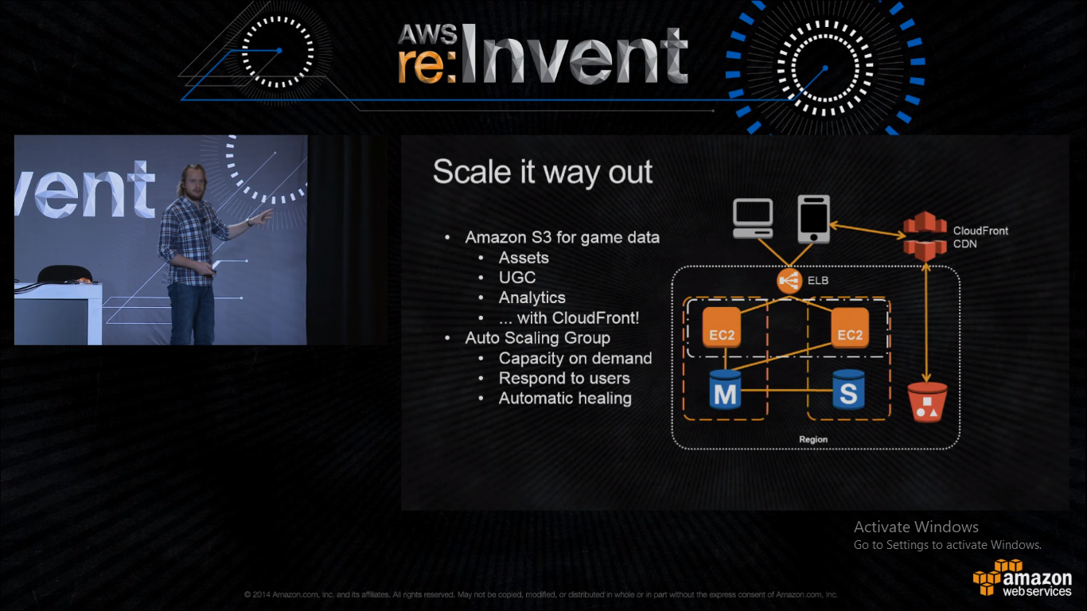

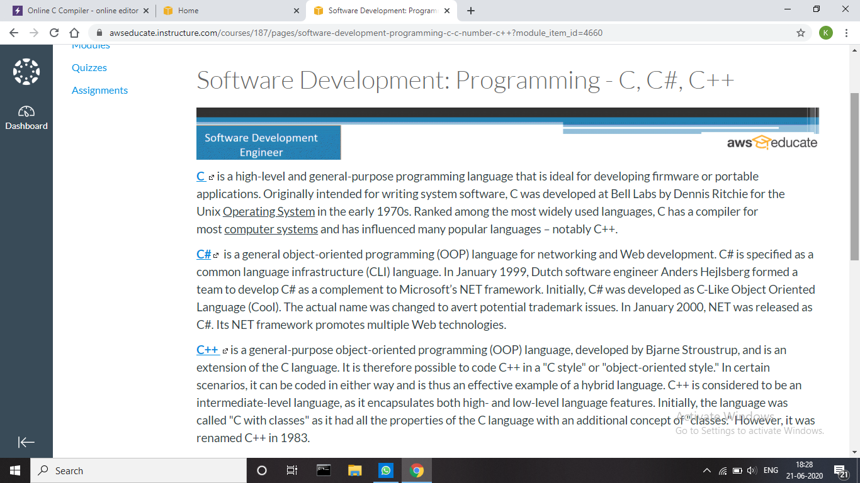

**Coding Challenges Details:**

## Problem: Write a C Program to rotate a Matrix by 90 Degree in Clockwise or Anticlockwise Direction. Implement (Both the rotations in single program using switch case statement).

## Matrix Rotation by 90 Degree in Clockwise Direction:

Input:  
Enter the total Number of Rows m: 3  
Enter the total Number of Columns: 3  
Enter the Elements of the Matrix:  
1 2 3 4 5 6 7 8 9  
Output:  
The Given Matrix is:  
1 2 3  
4 5 6  
7 8 9  
The Output Matrix After Rotation by 90 Degree in Clockwise Direction is:  
7 4 1  
8 5 2  
9 6 3

Matrix Rotation by 90 Degree in Anticlockwise Direction:

Input:  
Enter the total Number of Rows m: 3  
Enter the total Number of Columns: 3  
Enter the Elements of the Matrix:  
1 2 3 4 5 6 7 8 9  
Output:  
The Given Matrix is:  
1 2 3  
4 5 6  
7 8 9

The Output Matrix After Rotation by 90 Degree in Clockwise Direction is:  
3 6 9  
2 5 8  
1 4 7

**Hint:**  
Steps involved in Matrix Rotation by 90 Degree in Clockwise direction:

* Find the Transpose of the Matrix
* Reverse every rows of the Matrix

Steps involved in Matrix Rotation by 90 Degree in Anti clockwise direction:

* Find the Transpose of the Matrix
* Reverse every columns of the Matrix

**Solution:** Uploaded it in GitHub

